Waratek Support and Training Reference for Resellers

Introduction 4
Support Offerings 5
Executive Overview 5
Support Offerings Classifications 6
Standard Support 6
Premier Support 6
Support Details 7
Hours of Operation 7
Contacting Support 7
The Waratek Customer Portal 8
Access 8
Knowledge Base 9
Live Chat 9
Raising a Ticket 9
Documentation and Software 9
Email 9
Phone 9
Documentation 9
Support Ticket Management 9
Viewing Your Tickets 10
Ticket Status 10
Ticket Details and Tracking 11
Ticket Severity Definition 12
Service Level Objectives (SLO) and Support Standards 13
Definition of Support and Scope 14
Definition of Support 14
Scope of Support 14
Support Process 15
Support Levels 15
Level 1 15
Level 2 15
Level 3 16
Level 1 Detailed Description 17
Input 17
Activities 17
Output 18
Level 2 Detailed Description 19
Input 19
Activities 19
Output 19
Level 3 Detailed Description 20
Input 20
Activities 20
Output 20
Support Flowchart 21
End of Life Policy and Long Term Support for Waratek Products 22
Waratek Portal 22
Waratek Agents and Portal Dedicated 22
Onboarding Process 23
Milestones 23
Timelines 24
Training 24

Introduction
The purpose of this guide is to provide an overview of support, training and operating procedures for Waratek resellers. As a Waratek reseller, you will have access to our highly trained technical support staff as well as the right to use our Customer Support Portal (support.waratek com) with guides, search tools, knowledge base, live chat, case activity tracking and a support history of your products. Reviewing the procedures and processes described in this guide will enable you to provide the best possible service and fastest problem resolution, should you need it as well as working closely with Waratek contacts, for both training and ongoing support.

Note that this document is for reference purposes only. Please consult your contractual documentation for your exact terms and conditions.

Support Offerings
Waratek offers a comprehensive set of Technical Services and Support to ensure you have capability to deliver the high level of service you need for your customers. All Waratek resellers enjoy access to our highly trained technical support staff and resource-rich self-service Customer Portal.

Executive Overview

Customer Classification | Annual Service Offering Charge | Service Offering | Support Offering
Essential | n/a | n/a | Standard *
Advanced | n/a | n/a | Standard *
Elite | n/a | n/a | Standard *
Premier | n/a | n/a | Premier
* As part of your contractual agreement unless otherwise stated

Support Offerings Classifications

Standard Support
All resellers that have an active licensing contract, will automatically receive the applicable Support described below during the term of their respective agreement.

Key Features | Benefits | Designed For
Support Desk Open:  9am - 11pm UTC | - Access to highly trained support staff  - See Support Breakdown Section below for more details | - Small to medium resellers with a small to moderate license count for the customers
Phone support for critical issues 24x7x365 (Sev 1)
Standard Service Level Objectives (SLO) for Sev 1-4 issues
Email and web-based access
Access to Knowledge Base
Live Chat Channel

Premier Support
All resellers that have an active licensing contract that covers Premier Support, will automatically receive the applicable Support described below during the term of their respective agreement, in addition to the Standard Support described above.

Key Features | Benefits | Designed For
Phone support for critical issues 24x7x365 (Sev 2) | - Enhanced response and resolution times  - Personalized support  - Support when you need and want it | - Larger resellers that look for a more engaged approach and relationship with security with their customers  - Resllers with a larger license count
Enhanced Service Level Objectives (SLO) for Sev 1-4 issues
Dedicated Senior Support Engineer
Booked interactive support sessions

Support Details
The following details the breakdown of Waratek’s Support:

Support Features | Waratek Support Detail
Customer Service Contact Methods | Phone/Email/Customer Portal/Live Chat
Customer Support Contact Methods | Phone/Email/Customer Portal/Live Chat
Standard SLO Response Times (Sev 1-4) | 60mins/120mins/180mins/480 mins
Enhanced SLO Response Times (Sev 1-4) | 30mins/60mins/180mins/480 mins
Online ticket creation and tracking | 
Support Coverage (hours/day) | Support Help Desk Open:  Mon-Fri 9am-11pm UTC  Critical Support (Sev 1 & 2):  24x7x365
Unlimited Support Contacts
Unlimited Support Requests

Hours of Operation
Waratek’s Support team is available via web, email, live chat or phone each week from 9am UTC Monday to 11pm UTC Friday. An on-call Support Engineer is available to assist with critical issues 24x7x365.

Contacting Support
Waratek has made it as easy as possible to reach our dedicated Support team. There’s several ways to reach out to us, which are detailed below. To assist us in resolving your issue as swiftly as possible, when raising a support ticket please clearly state in the description field the scenario under which Waratek products allegedly fail. Please clearly state where you can and appropriate, any Steps to Reproduce, any Expected Output, and any Actual Output. In addition, please specifically provide the following information:

- Waratek Software Component Details
  - Waratek Product: e.g. Waratek Secure, Portal Dedicated
  - Product version: e.g. 25.2.0, 6.10.1
  - Issue type: e.g. Issue, Question
  - Java version, major and minor: e.g. Java 8u201, Java 7u301

- Environment Details
  - The operating system name/s and version/s:
e.g. Windows Server 2012 x64, RHEL 8
  - The JDK / .NET Framework vendor, name/s, version/s, data-model:
e.g. Oracle HotSpot 8u291 64-bit / Microsoft .NET Framework 4.5.8 x86
  - Where applicable, the affected application server name and version:
e.g. IBM WebSphere Application Server Network Deployment 8.5.5.9
  - Where applicable, the affected application/framework/database/datastore name and version:
e.g. Apache 2.5.12 / Microsoft SQL Server 2008 / Elasticsearch 7.2.0
  - Where applicable, the other Java / .NET agents name/s and version/s in use / affected:
e.g. Dynatrace OneAgent 1.216.

- Further Relevant Details
  - Problem descriptions including screenshots, configuration files and relevant log files for analysis and escalation purposes
    - Waratek Agent: events.log, waratek.properties, rules in use
    - Waratek Portal Dedicated: application.properties, mc.log, elasticsearch.log
    - Protected Application: e.g. application logs, stack trace logs, Java security policy

Furthermore, screenshots (e.g.: for the Portal SaaS/Dedicated) may need to be provided as well as security information (e.g.: for Java policies for Security Managers, Portal Dedicated deployment topology, etc) where applicable. Our ticket fields are designed to capture this information for your convenience.

The Waratek Customer Portal

Access
The recommended channel for contact is via The Customer Portal which can be accessed at https://support.waratek.com.

If you are visiting The Customer Portal for the first time, you will need to register. There is a registration option on the sign-in page. Once you have successfully registered, there is an internal verification step performed by Waratek staff. Once this verification is complete, you should receive a welcome email and have full access to The Customer Portal.

Knowledge Base
Waratek has an extensive Knowledge Base on The Customer Portal. This includes FAQs, Best Practice Guides, and other related documentation, a troubleshooting section and access to your product downloads and other related deliverables.

Live Chat
The Customer Portal provides you with the option to engage with our agents via Live Chat. We do recommend that you firstly search the Knowledge Base to see if you can resolve your query. You can use our Ai-powered Service Agent to put your questions to or search across the Knowledge Base.

Raising a Ticket
Once you are logged in to The Customer Portal, you can raise a ticket by selecting the option for “Create a Support Ticket”. We again recommend firstly searching the Knowledge Base or engaging with Live Chat first, especially if you believe your request is best handled in this manner.

Documentation and Software
Once logged in, you have access to all the Waratek documentation and the software downloads that are appropriate for your organization.

Email
You can also reach our Support Team via email at support@waratek.com.

Phone
If you have an urgent and suspected Severity 1 or 2 issue, you can contact our Support Team by phone:

USA: +1 312 654 5762
Rest of World: +353 1 223 8911

In the event that no agents are available, you can leave a voicemail message and we will respond promptly as soon as one of our agents is free.

Documentation
All Waratek documentation is accessible from The Customer Portal and also via our online SaaS Portal product. The documentation can also be accessed directly via https://waratek-docs.atlassian.net/wiki/spaces/WD/overview and your credentials to access will have been provided as part of our standard onboarding process.

Support Ticket Management
No matter what method you use to raise Support tickets, these tickets can all be viewed and managed through the Waratek Customer Portal: https://support.waratek.com. However, we strongly recommend raising a ticket for requests, as most requests require supplementary data and details. It also makes it much easier for us to track and share your request, as appropriate.

Viewing Your Tickets
Once you are successfully logged in to The Waratek Customer Portal, you will see the overview page. At the top of this page, select the “Go To Customer Portal” link and you will be brought to the page that shows your tickets.

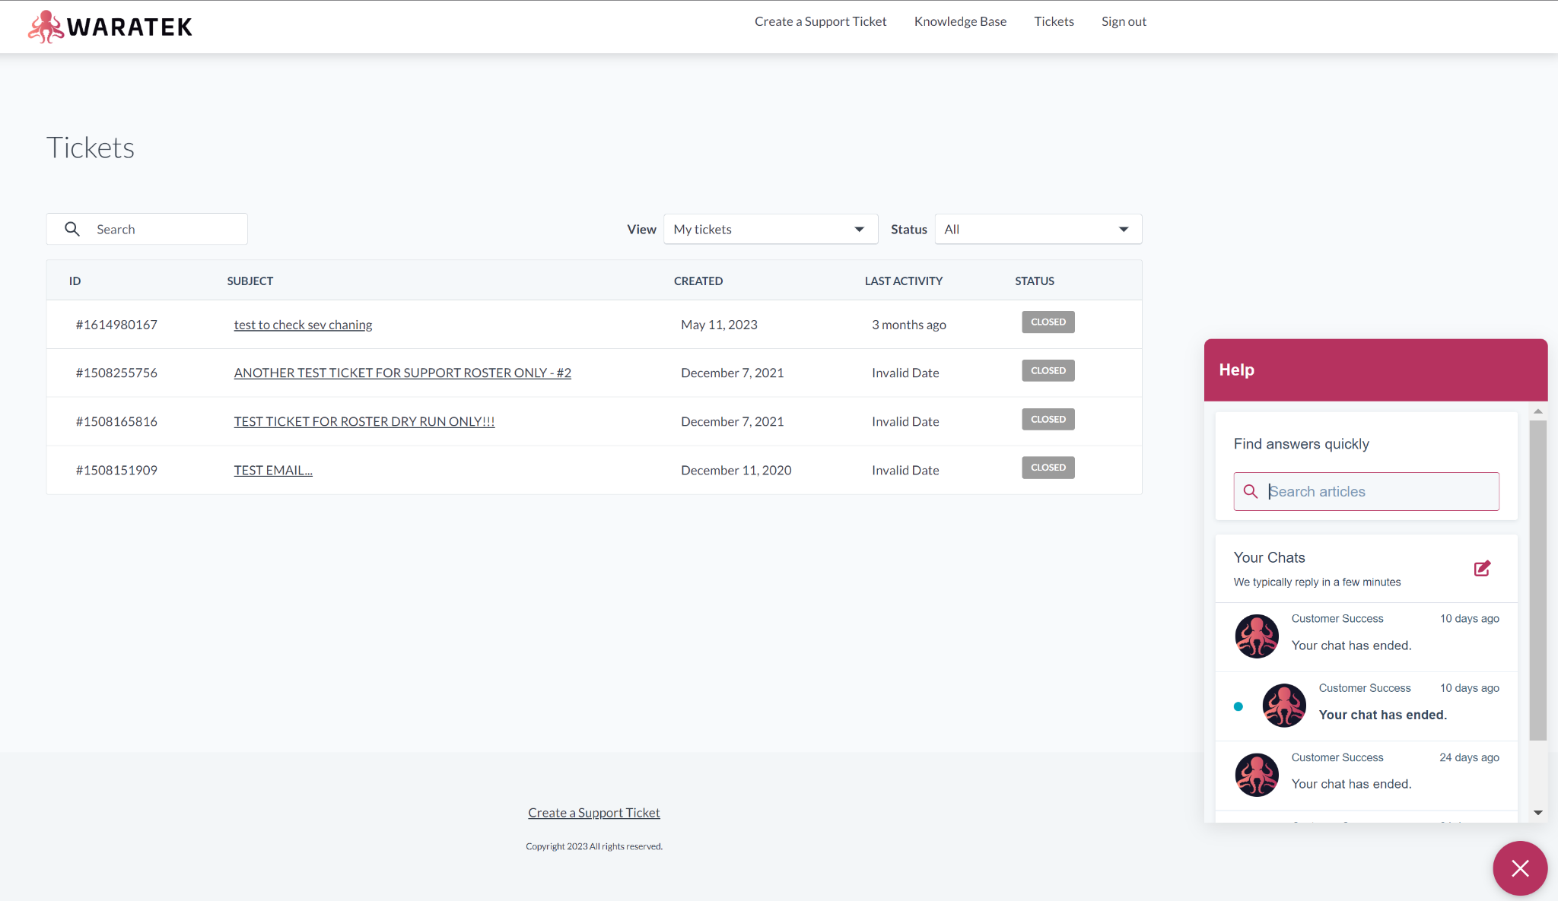

Ticket Status
Waratek support tickets will have one of the following five states:

New - this represents the initial status of the ticket.
Waiting On Support - the onus is on Waratek Support to provide information and progress the ticket towards resolution
With Engineering - the onus is on Waratek Engineering to provide technical information and progress the ticket towards resolution.
Waiting On Customer - the onus is on The Reseller to provide information to progress the ticket towards resolution
Closed - the ticket has been resolved and agreed to be closed.

The reporter of the ticket will be updated via email as a result of any further conversation or update in the ticket.

Note: After ticket closure, The Reseller contact that raised the ticket (the reporter) has the option to provide feedback on how well Waratek handled the request.

Ticket Details and Tracking
When you click on one of your tickets that you are viewing, you are presented with a detailed view of the history of the conversations relating to that ticket.

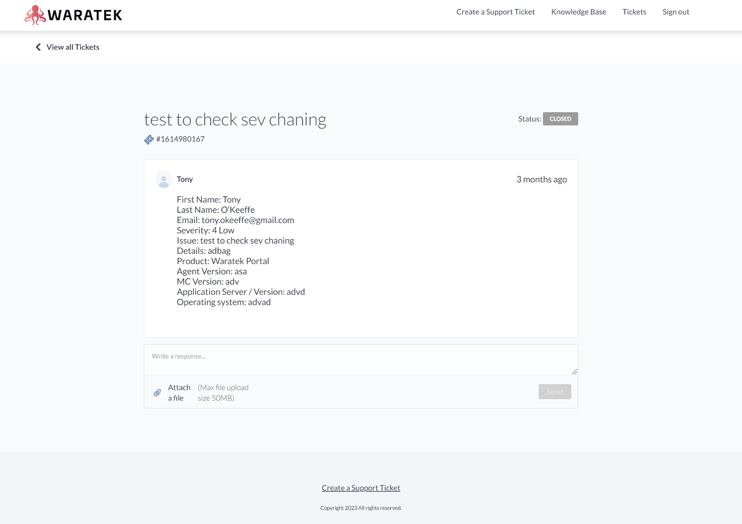

Ticket Severity Definition
Ticket Severity may be proposed by The Reseller when raising a ticket but is confirmed by the Waratek Customer Support Team when acknowledging and responding. Severity is normally based on a combination of the impact and urgency of the request.
Waratek Support Severity Levels are:

- Severity 1 - No further work can be performed, or processing capability is so limited that the probability of a serious operational backlog is created. There is currently no convenient work-around, and the error requires immediate attention. Scope is normally confined to Production or end-user facing environments.
Waratek will have support staff working to resolve the error as per our Service Level Objectives (SLOs) below and will ensure continuous support until the error has been resolved to The Reseller’s satisfaction.
In addition, Waratek will make every effort to resolve or temporarily circumvent the error within four hours after correct and accurate notification.
Waratek will provide the contact persons designated with a status report not less than every two hours, unless expressly waived by The Reseller.
Waratek will make a permanent correction through a maintenance version of the Product and/or Service.
- Severity 2 - Processing capability is limited, and the error has some significant adverse impact on the end customer's operations. Scope is normally confined to Production or end-user facing environments.
Waratek will give immediate attention to the error and will make every reasonable effort to circumvent the error within one Working Day after correct and accurate notification.
Waratek will provide the contact person designated with a status report every two hours, unless expressly waived by The Reseller.
Waratek will make a permanent correction through a maintenance version of the Software and/or Service.
- Severity 3 - Day to day operational errors not classified as Severity 1 or Severity 2. Scope is normally confined to environments that exclude Production or end-user facing environments.
Waratek will give prompt attention to the error and will make every effort to provide a solution as soon as reasonably possible.
If required, Waratek will make a correction in its next maintenance version of the Software.
- Severity 4 - Requests not classified as Severity 1, 2 or 3.

Service Level Objectives (SLO) and Support Standards
The Waretek Support SLOs for response times are:

Severity/Support | Standard Support | Premier Support
Severity 1 | 60 minutes | 30 minutes
Severity 2 | 120 minutes | 60 minutes
Severity 3 | 3 hours | 3 hours
Severity 4 | Next business day | Same business day

The Waratek Support SLOs for resolution are:

- Severity 1 - Waratek will make every effort to resolve or temporarily circumvent the error within four hours after correct and accurate notification.
Waratek will provide the contact persons designated with a status report not less than every two hours, unless expressly waived by The Reseller.
Waratek will make a permanent correction through a maintenance version of the Product and/or Service, as soon as commercially feasible.
- Severity 2 - Processing capability is limited, and the error has some significant adverse impact on the end customer's operations. Scope is normally confined to Production or end-user facing environments.
Waratek will give immediate attention to the error and will make every reasonable effort to circumvent the error within one Working Day after correct and accurate notification.
Waratek will provide the contact person designated with a status report every two hours, unless expressly waived by The Reseller.
Waratek will make a permanent correction through a maintenance version of the Software and/or Service, when commercially feasible.
- Severity 3 - Day to day operational errors not classified as Severity 1 or Severity 2. Scope is normally confined to environments that exclude Production or end-user facing environments.
Waratek will give prompt attention to the error and will make every effort to provide a solution as soon as reasonably possible.
If required, Waratek will make a correction in its next maintenance version of the Software, when commercially feasible.
- Severity 4 - Requests not classified as Severity 1, 2 or 3.

Definition of Support and Scope

Definition of Support
Waratek’s Support Team provides aid and assistance to resellers of Waratek’s products. This aid is requested and provided using the various communication channels as described in earlier sections of this document. Our overarching objective is to ease both the successful installations of Waratek products, and ensure their satisfactory operation. Normally, Waratek Support does not deploy or configure the Waratek products, perform upgrades or directly provide customizations such as patches but the Support Team will work closely with the other reseller Teams and Departments in that respect.

In summary, The Waratek Support Team focuses on ensuring the product operates and performs to its published specifications.

Scope of Support
- Handling and managing requests from Waratek customers
- Analyzing issues that prevent the Waratek product or protected application of the customer from operating as it was designed, and determining if the problem was a result of a defect or misconfiguration
- Escalating and explaining discovered issues to the Waratek Engineering team and updating The Reseller about the status
- Guiding The Reseller to general documentation related to their questions
- Providing basic instructions to properly configure the product when The Reseller is unaware of how to configure Waratek to achieve specific behaviors
- Receiving and understanding The Reseller's proposals and correctly communicating these to the Waratek Product Management team
- Understanding any challenges that The Reseller is trying to solve and providing best practices to get the most benefit from Waratek products

Support Process
Waratek, like any professional organization, has a Support Process. This process breaks down how the levels of support are progressed and who provides that support. It is assumed that there is a ‘Level 0’ Support Level - this represents the end customer or The Reseller performing self-service support without the need to engage with any support representatives, e.g. checking the documentation or searching the Knowledge Base. It is expected that The Reseller is responsible for performing Level 1 and Level 2 (L1/L2) support.

Support Levels

Level 1
Level 1 Support is the first level of support where the customer directly engages with The Reseller. First level support is either provided by The Reseller or some other external provider of Support on behalf of The Reseller. This includes but is not limited to the following:

A) Information collection and analysis of end customer requests
B) Confirmation that all relevant information and data has been provided and the request is understood
C) Basic troubleshooting and issue reproduction where possible using product knowledge to address common and basic problems
D) Request reporting, administration and tracking
E) Escalation to Level 2

Level 2
Level 2 Support is the second level of support where the customer directly engages with The Reseller. Second level support is provided by The Reseller or some other external provider of Support on behalf of The Reseller. This includes but is not limited to the following:

A) Handles escalated requests from Level 1 and confirms Level 1 Support has been conducted as expected
B) Proves a more technical and knowledgeable set of personnel to confirm and address installation and configuration issues not limited to core Waratek products (installation and configuration of data repositories such as Elasticsearch, Oracle and Postgres databases, identity and trust stores)
C) Detailed troubleshooting, analysis and issue reproduction where possible
D) Escalation to Level 3

Level 3
Level 3 Support is the third level of support where The Reseller engages with Waratek Support. Third level support is provided by Waratek to The Reseller directly via or some other external provider of Support on behalf of The Reseller and includes but is not limited to the following:

A) Handles escalated requests from Level 2 and confirms Level 2 Support has been conducted as expected by The Reseller
B) Provides vendor technical subject matter experts for issues that cannot be handled by Level 2
C) Issue reproduction, analysis, root cause identification, suggested workarounds and resolution, all where possible

Level 1 Detailed Description

Input
Initial contact, details and description from the customer to The Reseller.

Activities
- Verify contact details and contact preferences.
- Confirm the exact program versions of the Waratek Software components.
  - Waratek Agent: e.g. Waratek Secure, Portal Dedicated/SaaS
  - Product version: e.g. 24.1.0, 6.4.2
  - Issue type: e.g. Issue, Question
  - Java version, major and minor: e.g. Java 8u201, Java 7u301
- Confirm environment details
  - The operating system name/s and version/s:
e.g. Windows Server 2012 x64
  - The JDK / .NET Framework vendor, name/s, version/s, data-model:
e.g. Oracle HotSpot 8u291 64-bit / Microsoft .NET Framework 4.5.8 x86
  - Where applicable, the affected application server name and version:
e.g. IBM WebSphere Application Server Network Deployment 8.5.5.9
  - Where applicable, the affected application/framework/database/datastore name and version:
e.g. Apache 2.5.12 / Microsoft SQL Server 2008 / Elasticsearch 8.8.2
  - Where applicable, the other Java / .NET agents name/s and version/s in use / affected:
e.g. Dynatrace OneAgent 1.216.
- Collect relevant detailed problem descriptions including screenshots, configuration files and relevant log files for analysis and escalation purposes
  - Waratek Agent : events.log , waratek.properties, rules in use
  - Waratek MC: application.properties, mc.log, elasticsearch.log
  - Protected Application: e.g. application logs, stack trace logs, Java security policy
- Work with any FAQs, work with the documentation and work with any L1 knowledge base to provide resolutions for quick turnaround.
- Check if you can complete or have updated the following fields:
  - All Info In ticket
    - check this property when you feel that you have all the information required in order to progress this ticket towards resolution.
  - Priority
    - This is the level of urgency or priority that the customer associates with this ticket.
  - Severity
    - Assign the appropriate severity level before the initial response to the ticket. The Severity level should be set based on the earlier chapter definitions.
- Acknowledge the ticket with the customer
  - If any of the required information is missing, request so in the acknowledgement
  - If all required information is present, assign the ticket as follows:
    - If you believe you have a resolution, assign the ticket to yourself.
Confirm the ticket status is “WAITING ON SUPPORT” or equivalent while preparing a resolution, and once you have provided the resolution to the customer, then confirm the ticket Status is “WAITING ON CUSTOMER” or equivalent
    - If you believe you cannot provide a resolution, assign the ticket to or open a new ticket with the next Level team, and confirm your ticket status is “WAITING ON SUPPORT” or equivalent

Output
Completeness of input and provide results of research in any Knowledge Base.
Either update the ticket for resolution or provide all information for escalation to L2.

Level 2 Detailed Description

Input
Ticket has been completed with relevant information by L1.

Activities
- Confirm the validity of the installation and configuration.
- Collect any relevant missing information.
- Work with the Knowledge Base to investigate whether there have been known issues or similar problems identified and resolved.
- Provide advanced resolutions based on the findings.
- Assist customers to re-configure the components to fix certain issues.
- If no resolution can be found prepare the ticket for L3 escalation
  - document in detail how the issue can be duplicated and possibly confirmed in a Test-Lab sandbox environment.
- Assist next support Level with communication to the customer, and collect possible advanced debug material.

Output
Gather all relevant information and provide a detailed description of a possible desired solution. Update the ticket towards resolution, by either reverting back to L1 and/or the Customer for more information, or by escalation to L3.
Provide debugging output and all relevant information where needed.
Continue to handle the customer communication and manage the ticket.

Level 3 Detailed Description

Input
Output from L2, which should at this stage not be a documentation issue or a mis-configuration.

Activities
- Provide mentoring and guidance to lower support levels.
- Advanced debugging and troubleshooting of reported issues.
- Code reviews and bug fixes.
- Problem duplication and root cause analysis.
- Dates for resolution, possibly with a new release.

Output
Fix of reported issues or advice on fix timelines.

Support Flowchart
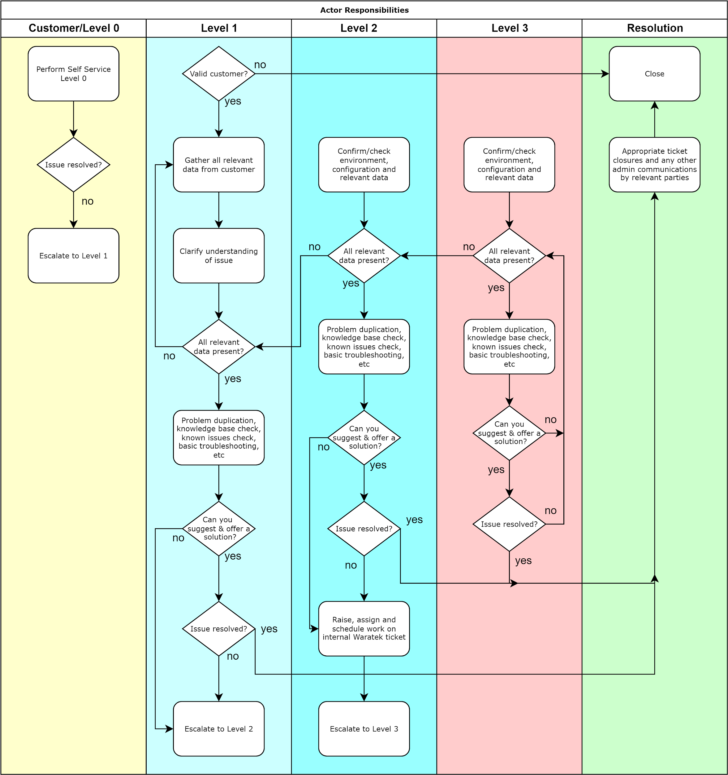

End of Life Policy and Long Term Support for Waratek Products
All products eventually reach their natural end of life and are usually replaced with new and improved versions. Waratek will endeavor to provide as much visibility into this process as possible and we will provide prior notice before the “end of life” (EOL) of any major software feature or major functionality. Waratek provides a deprecation notice of products and features which communicate their imminent EOL in each set of Release Notes.

Waratek strongly encourages customers to stay current with the latest versions of our products to take advantage of new enhancements and the latest features.

Waratek Portal
As the Waratek Portal is a Software-as-a-Service (SaaS) offering that is fully maintained and updated by Waratek, the Long Term Support (LTS) for this product is effectively not applicable.

Portal Dedicated has LTS as per below.

Waratek Agents and Portal Dedicated
The various Waratek Agent products, such as Secure for Java, Elevate, and .NET as well as Portal Dedicated will have support for up to 18 months from their release date, unless otherwise stated. Occasionally, some versions may have a reduced LTS as certain features or third-party dependencies may have a temporary or shorter life and are expected to be replaced or updated in the near future.

Onboarding Process

Milestones
All resellers are provided with the appropriate technical and onboarding training, education as well as assistance to provide the best experience for you and your end customers on their Journey to Production.

The overview of the typical milestones you can expect to reach during this process are shown below:

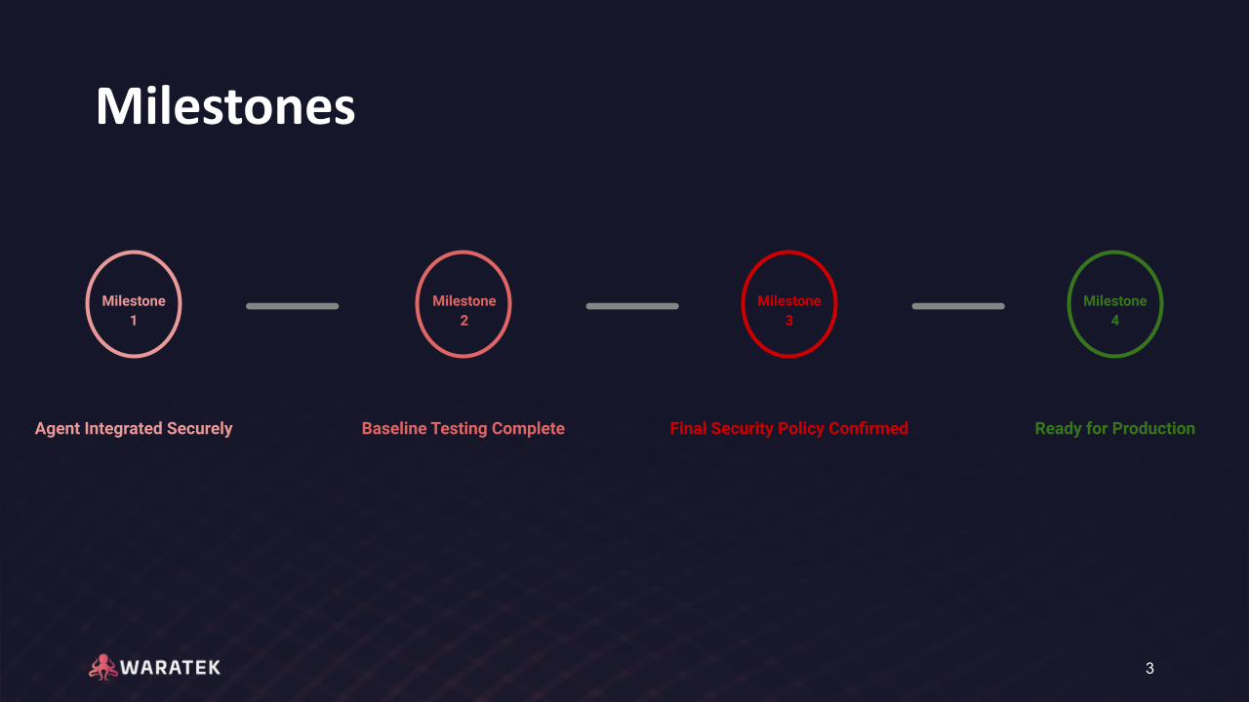

You may decide to apply your own set of milestones with the expected achievements.

Timelines
While the timelines for reaching these milestones are clearly dependent on each customer, once the relevant resources are available, we have found the below timeline typical along with the expected achievements at each milestone:

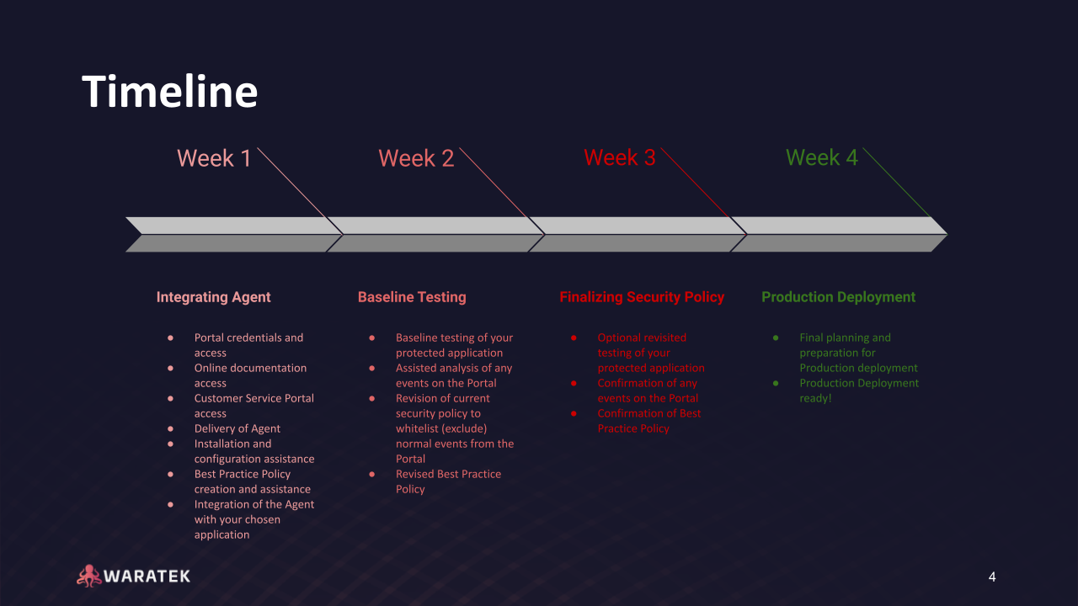

Training
Waratek Customer Success staff deliver training to your staff as a part of our standard offerings. This is provided as an integrated activity during a sample onboarding process. During this sample onboarding process which we will refer to as a sample Journey to Production, your staff will be fully trained on the following activities and more:

- How to access the Waratek Customer Support Portal
- How to access and install your Waratek products
- How to configure your Waratek products
- How to integrate your Waratek products with your application
- A detailed understanding of the configuration options and how they influence behavior
- How to update your products

This education and training will cover all the appropriate aspects and features of all of the Waratek products to which you have access. We undertake to not only show you from a hands-on, practical perspective how to use our products and their features but we will supervise your own staff’s personal efforts, ensuring that you have first-hand experience. This practical training will be conducted using a pilot application or small group of applications (e.g. a single small domain) of your choice. Unlike other companies that may deliver training materials and expect you to educate yourself, we endeavor to ensure that you have personally and successfully attempted all the activities that you need to perform, in order to confidently use our products as per your requirements and maximize the value obtained from Waratek. While there is no formal certification process, our staff will stand beside you onboarding your first few customers, stepping forward or backwards as needed to ensure you have the freedom and support you require.

There is currently no restriction on the number of your staff that undergo training during this onboarding process. Based on the milestones above, our experience has shown that by the end of the first sample Journey to Production, our resellers are competent and confident working with Waratek products and the protection they provide. Waratek staff are always happy to assist and refresh you on any specific aspects of education or training, if necessary.

Training times are flexible as we understand that you and your teams have other commitments that need to be met. While we offer flexibility for these times, we strongly encourage that you set aside 2-3 hours per day during one week for these activities and expect the total time required to be under 10 hours. Training is normally conducted remotely with interactive video sessions, as this is likely how a large number of your customers’ onboarding will happen.

When new releases of our products are made available, Waratek staff will inform you of the relevant changes and new features so you can decide if and when you wish to update your Waratek products with these new releases and how to correctly use any such new features.

Waratek Customer Success staff will furnish you with more details and will answer any questions that you might have during the onboarding and training process itself.


Waratek WW HQ | 1st Floor - Suite 3, 57-59 Sir John Rogerson's Quay, Dublin Docklands, Dublin 2, D02 F242, Ireland
Waratek Americas | 159 N. Sangamon, Suite 200, Chicago, Illinois 60607
(HQ) +353 1 475 8803 | (US) +1 (872)-469-8605

